1. -- Show only the employee name and job title columns

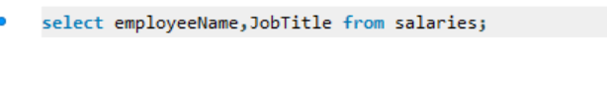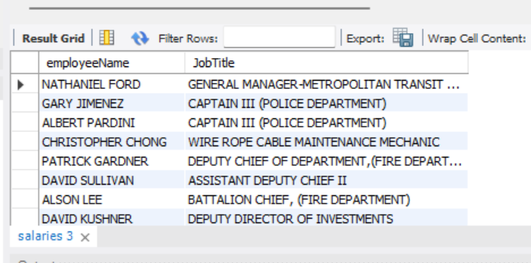

1. -- Show the number of employees in the table

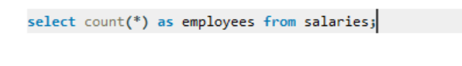

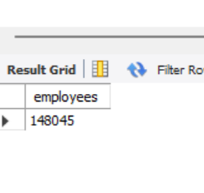

1. -- Show the unique job title in the table



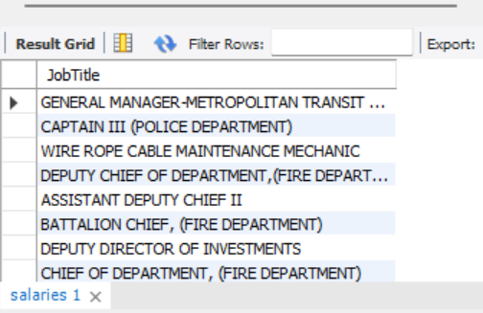

1. -- Show the job title and overtime pay for all employees with overtime pay greater than 50000

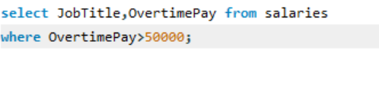

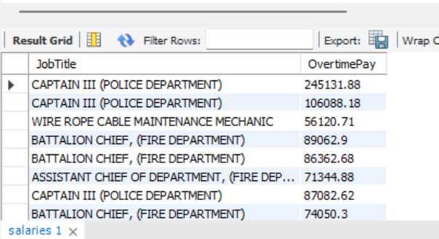

1. -- Show the average base pay for all employees

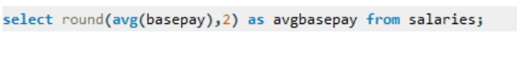

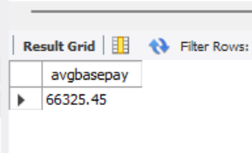

1. -- Show the top 10 highest paid employees

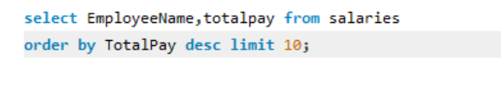

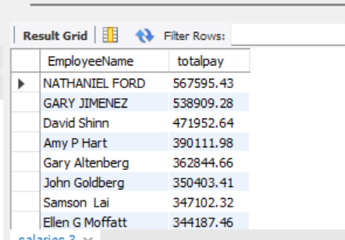

1. -- Show all employees who have the word manager in their job title

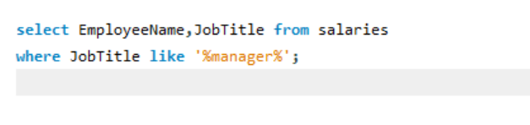

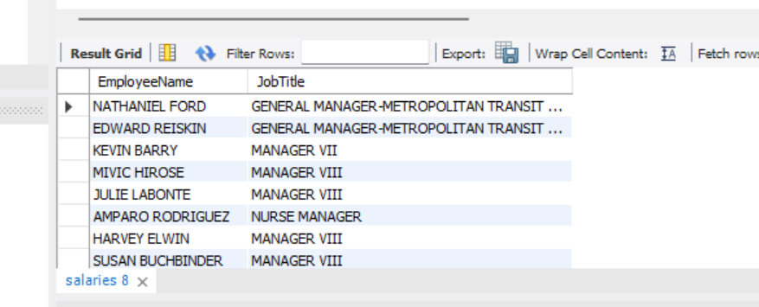

1. show all employee with a job title not equal to manager

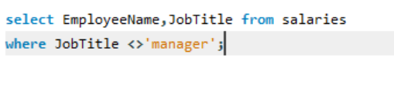

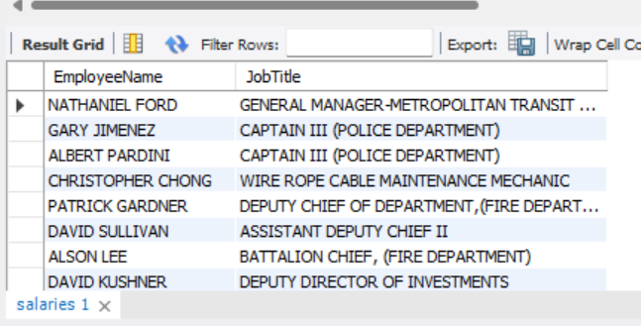

1. -- Show all employee with a total pay between 50000 and 75000

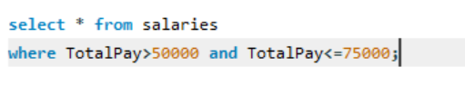

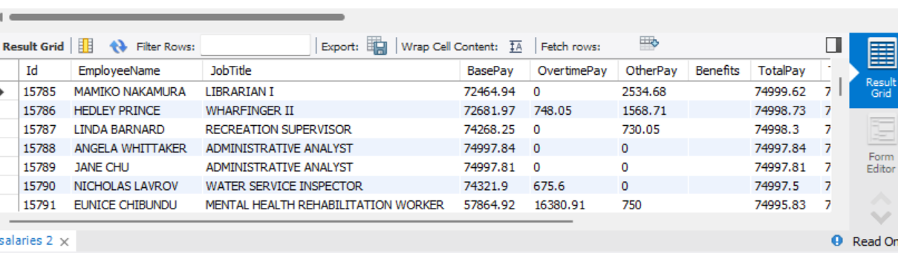

1. -- Show all employees with a base pay less than 50000 or a total pay greater than 100000

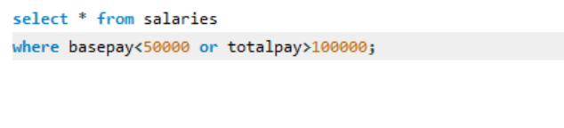

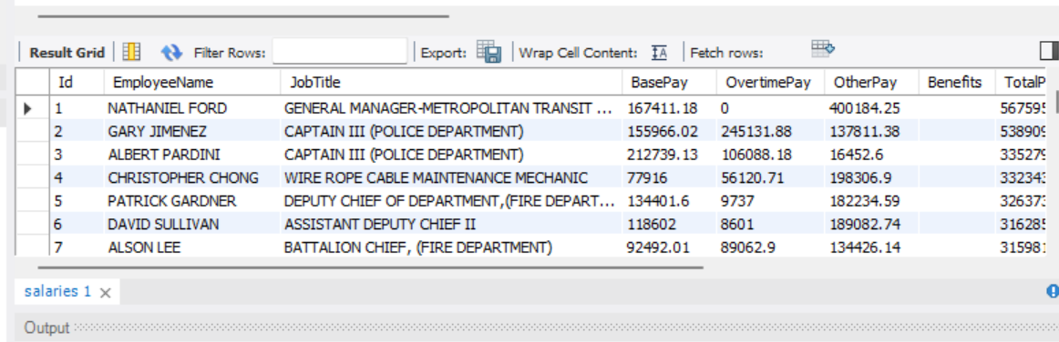

1. -- Show all employee with a total pay benefits value between 125000 and 150000 and a job title containing the word director

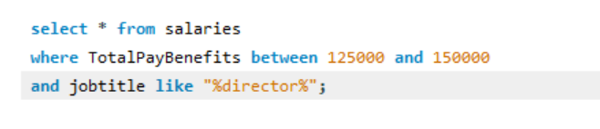

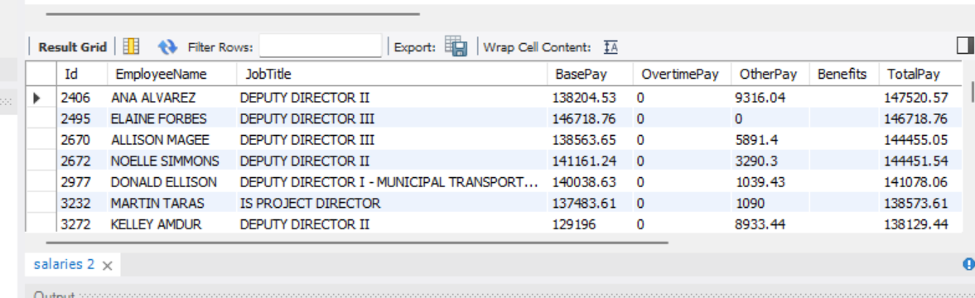

1. -- Show all employee ordered by their total pay benefits in descending order

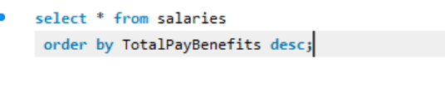

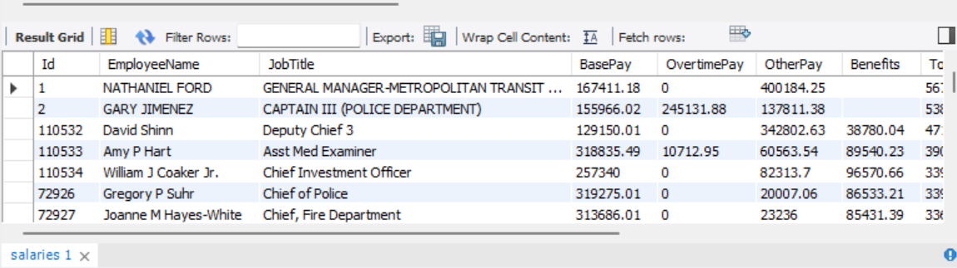

1. -- Show all job title with an average base pay of at least 100000 and order them by the average base pay in descending order

